

National University of Singapore

Intelligent Systems Masters Course Project

**Heart Watch**

**A diagnostic application for Cardiovascular Diseases**

Members

**Pee Kian Soon (A0213510B)**

**Mahathir bin Humaidi (A0213486A)**

**Tang Shao Qiang (A0213558A)**

Contents

Contents 2

1. Business proposition 4

2. Knowledge acquisition and research methods 4

2.1 Interview of domain expert 4

2.2 Dataset 5

2.3 Knowledge discovery with decision trees 6

3. System design and implementation 7

3.1 System architecture 7

3.2 Application implementation 8

4. System evaluation 9

4.1 Cross-validation and variation in decision tree depth 9

4.2 Usage of Questionnaire View 1 9

4.3 Usage of Questionnaire View 2 12

4.4 Result Page 14

5. Conclusion 15

6. References 16

Appendix 1: Project Proposal 17

Appendix 2: System Functionalities and Course Work Knowledge 17

Appendix 3: Installation and User Guide 17

1 Deployment 17

Appendix 4: Personal Report 24

**Table of Figures**

Figure 2.1 Cleveland Heart Disease dataset from UC Irvine repository 6

Figure 2.2 Decision tree built with Cleveland Heart Disease dataset 7

Figure 2.3 Rules 7

Figure 3.1 Logical System Architecture 8

Figure 3.2 Steps in developing Heart Watch application 9

Figure 4.1 Questionnaire 1 (Question 1) 10

Figure 4.2 Questionnaire 1 (Question 2) 10

Figure 4.3 Questionnaire 1 (Question 3) 11

Figure 4.4 Questionnaire 1 (Question 4) 11

Figure 4.5 Questionnaire 1 (Question 5) 12

Figure 4.6 Questionnaire 1 (Question 6) 12

Figure 4.7 Questionnaire 2 13

Figure 4.8 Result Page 14

**Table of Tables**

Table 4.1 Performance metric for 10-fold validation of decision tree modelling 9

Table 4.2 Certainty factors of contracting CVD with different lifestyle habits 13

# Business proposition

Cardiovascular disease (CVD) is a leading cause of death globally and 17 people in Singapore die from CVD every day. A doctor has a wide variety of non-invasive and invasive tests at his disposal to diagnose CVD patients. These tests can be expensive and time-consuming for both the patient and the doctor. Therefore, a doctor needs to figure out the most efficient method to predict onset of CVD in his patients.

Our team proposes here an application that is able to quickly diagnose if a patient might contract CVD with a few targeted queries about some clinical measures and lifestyle practices of the patient. The application matches the information provided about the patient with a rule engine that is constructed in consideration to a decision tree model trained using a historical dataset of patients, some of who may have CVD. This application is user-friendly as it guides the user through a dedicated set of queries. The user can quickly derive a first prediction about the patient’s possibility of contracting CVD, which can be a critical and timely reminder to initiate further medical investigations. Such pre-emptive efforts that can be realized with this system may help to save more lives, via an early warning process.

A short questionnaire designed from rules derived from a historical dataset of CVD predictors. A doctor will order a single non-invasive test, the Thallium stress test, and few more non-invasive tests as required by the questionnaire. Based on the rules set by our machine learning algorithm, the questionnaire is able to predict the onset of CVD.

# Knowledge acquisition and research methods

## Interview of domain expert

A general practitioner (clinical domain expert) is interviewed to obtain the relevant background patients information pertaining to cases of cardiovascular diseases.

**Questionnaire with GP (Selected questions):**

Question 1:   
What is the definition of heart diseases?

Reply: Any condition that affect the heart.

Question 2.   
What are the most important signs and symptoms of heart diseases?

Reply: Typical Chest pain; Breathlessness; Decreased effort tolerance; orthopnea; giddiness; hypotension; Levine's sign; decreased blood pressure; typical ECG findings

Question 3:   
What are the current methods used by physicians to determine presence of heart diseases?

Reply: Strong clinical suspicion; history taking and examination; risk factors stratification ; ECG

Angiogram for the tertiary care and CK/CKMB/ Trop T blood test

Question 4:   
What are the accuracies of these methods?

Reply: Dependant on the Dr assessing

Question 5:   
Among the factors shown above, which do you think will be the most indicative factors for presence of heart disease? Why is it so?

Reply: Primary care would be high index of suspicion and typical ECG findings; along with high risk factor straticfication . As we do not have assess to Trop T and angiogram.

Easily done in the clinic.

Question 6:   
Among the factors shown above, which do you think will be the least indicative factors for presence of heart disease? Why is it so?

Reply: Patient's complaints of chest pain. Pain is subjective and certain times IHD do not present with chest pain.

Question 7:   
How is blood sugar level related to cardio health?

Reply: Diabetes affects the microvascular health of all organs and also damages their nerve endings; especially the heart. It also is part of the big 3 metabolic diseases (hyperlipidemia and hypt) ,

Question 8:   
Are there any other factors which you think can be a good predictor of heart diseases (smoking, alcohol, hereditary etc.)?

Reply: Smoking; familial history ; high alcohol consumption; sedentary lifestyle; high trans fats diet

Question 9:   
Do you know of any similar products in the market? What is your assessment of these products?

Reply: Nil

Question 10:

Are there any good (or authoritative) database of heart diseases that you think will be useful for this project?

Reply: Nil

Question 11:

Do you think AI can outperform doctors in illness diagnosis especially in the area of heart disease? Otherwise what kind of roles should they play in this arena?

Reply: It will be a complicated AI. Medical judgement cannot be easily replicated with our current equipment.

Plus it is important to have a very accurate AI as this is a matter of life and death.

## Dataset

The dataset used is the Cleveland Heart Disease dataset taken from the UCI repository **[1]**. This dataset consist of 13 clinical parameters **[2]** that provide a measure of the patient’s condition with respect to the likelihood of him or her having cardiovascular disease. The 13 parameters are as follows:

1. Age
2. Sex
3. Chest-pain Type (typical angina, atypical angina, non-angina, asymptotic)
4. Resting Blood Pressure
5. Serum Cholesterol
6. Fasting Blood Sugar
7. Resting ECG (Electrocardiogram)
8. Maximum Heart Rate Achieved
9. Exercise-Induced Angina
10. ST Depression Induced by Exercise Relative to Rest
11. Peak Exercise ST Segment (upsloping, flat, downsloping)
12. Number of Major Vessels Coloured by Fluoroscopy
13. Thallium stress test results (normal, fixed defect, reversible defect)

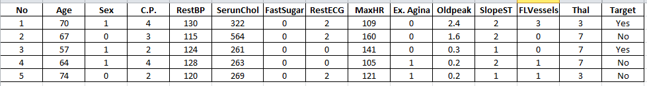

Figure . Cleveland Heart Disease dataset from UC Irvine repository

## Knowledge discovery with decision trees

The decision tree technique will be used to derive the best indicative factors based on the background data from past medical diagnoses of doctors. 270 patients’ records are used and 13 key factors are identified for use in the diagnosis of CVD. Background data (Cleveland dataset) is used to generate both training and testing datasets, with a 10-fold validation step, which shows that a decision tree with a depth of 3 has the best AUC (Area under the Receiver Operating Characteristic Curve) score. A decision tree (Figure 2.2) is generated, using the machine learning software Orange, to find the best attributes that produce the highest information gain or lowest entropy. The parameters and corresponding thresholds, are hard-coded into 8 rules (Figure 2.3) using the Experta Python package. These 8 rules will classify the patient diagnosis into Yes (Positive) or No (negative) with corresponding probability values.

~~T~~he 8 rules are made up of 6 parameters: the Thallium test results, the chest pain type, the maximum heart rate achieved, presence of exercise-induced angina, the number of major blood vessels colored by fluoroscopy and resting ECG.

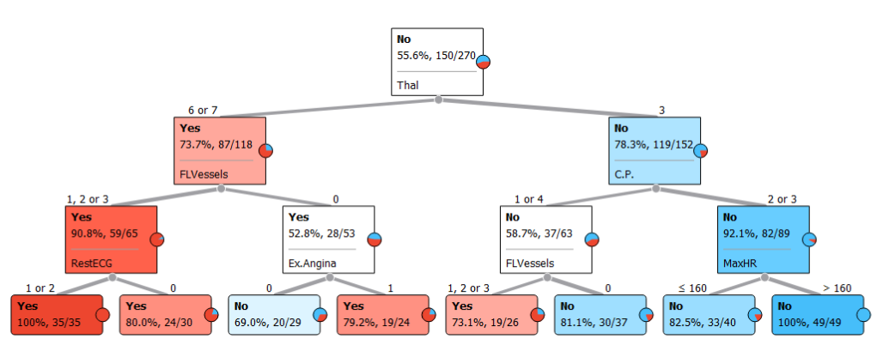

Figure . Decision tree built with Cleveland Heart Disease dataset

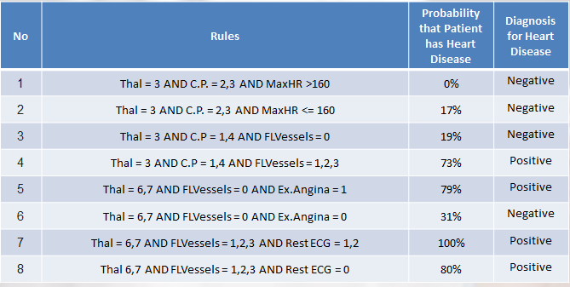

Figure . Rules

# System design and implementation

## System architecture

The Application logical system architecture is presented schematically in Figure 3.1. On the client side, the user accesses the HTML landing page of the application (questionnaire01.html). After the user gives his input for the first form (1st question on Thallium test results), the business logic in views.py redirects the user to the next question in the corresponding form, defined in forms.py. The user continues to give inputs for 2 other forms in the questionnaire01.html page, before an invocation in views.py directs the user to the questionnaire02.html page which contains the form that query the user about his or her CVD-related lifestyle habits. After the user send the POST request back to the backend views.py processes by answering Questionnaire02, rules matching and triggering will be carried out in rules.py and the matching rules will be returned to views.py. Finally, an invocation in views.py will render the result.html page to display the results of the diagnosis which will consist of the conclusion of whether the patient might be having CVD, and the probability of having or not having the disease.

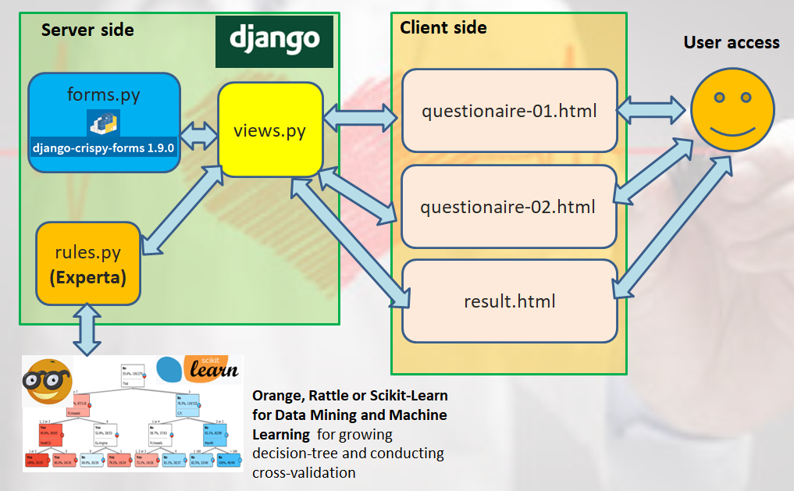

Figure . Logical System Architecture

## Application implementation

A decision tree is generated by the Orange Data Mining software **[3]**, from which 8 rules are derived. The same decision tree is also generated with Rattle **[4]** and Scikit-Learn **[5]** Python package for comparison and verification. The Cleveland dataset is split into 10 subsets, 9 of which are used for training and the remaining data subset being used for cross-validation which is carried out with Orange and the Python-based Scikit-Learn package. The resulting 8 rules are hard-coded and implemented in the Django-based **[6, 7]** server side application using the Experta **[9]** library. These rules are captured and implemented in the file rules.py, which will be accessed by views.py upon activation by user input into the forms, via the two questionnaires html pages. After comparison of user input and rules have been carried out in Experta, the rules that are fired will be returned to views.py, in which they will be sent to the method render( ), to be displayed in the final result.html page.

The user will be first brought to the starting page - questionnaire01.html - of the application on logging-in . A business logic coded in views.py will direct users to different sequences of questions based on the inputs of user for the earlier questions. In this way, the application works efficiently and dynamically to deliver only the relevant and critical questions to the user (doctors or patients), so that an accurate diagnosis can be arrived at in the shortest time.

The business logic is implemented in a series of if-else statements in views.py, within the dedicated classes written for each question and its associated form. Within each class, a decision on the next relevant question to direct the user to will be made and the method HttpResponseRedirect will be invoked to pass control over to the class that will activate the corresponding form and render the questionnaire01 HTML page. All the various questions and their corresponding forms are implemented within the same HTML page. HTML forms styling are achieved with the Boothstrap framework **[8]**.

Figure 3.2 gives an overview of the processes involved in developing the model and finally deploying the decision tree rules in the rule engine for real-time use.

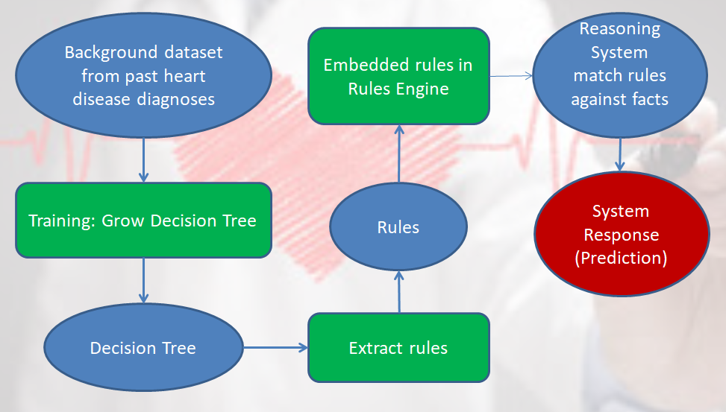

Figure . Steps in developing Heart Watch application

# System evaluation

## Cross-validation and variation in decision tree depth

A 10-fold validation is carried out on the Cleveland dataset, and decision tree depths of 3 to 5 are explored. As seen in Table 1, a decision tree depth of 3 gives the best results for the various metric of performance, such AUC and Precision. The decision tree with three levels of splits at three sets of nodes is selected as the final model to use within the rule engine. The rule engine is implemented with the Experta library.

Table . Performance metric for 10-fold validation of decision tree modelling

|  |  |  |  |  |  |
| --- | --- | --- | --- | --- | --- |
| **Model** | **AUC** | **CA** | **F1** | **Precision** | **Recall** |
| Tree Depth 3 | 0.806 | 0.785 | 0.784 | 0.785 | 0.785 |
| Tree Depth 4 | 0.796 | 0.759 | 0.756 | 0.761 | 0.759 |
| Tree Depth 5 | 0.781 | 0.733 | 0.730 | 0.734 | 0.733 |

## Usage of Questionnaire View 1

There are 6 questions (Figures 4.1 to 4,6) in Questionnaire 1, but only a different set of 3 questions will be delivered to the user each time, depending on the input given by the user in response to the earlier questions. After the user has given inputs for the 3 questions, these inputs will be compared to the rules in rules.py, under the action of the business logic implemented in views.py. When a match to a particular rule is realized, the probability of diagnosis for CVD associated with that rule will be returned to view.py, where the application will be routed to an HTML page showing a second set of questionnaire which queries the user about his or her lifestyle habits that might contribute to the increased possibility of contracting CVD.

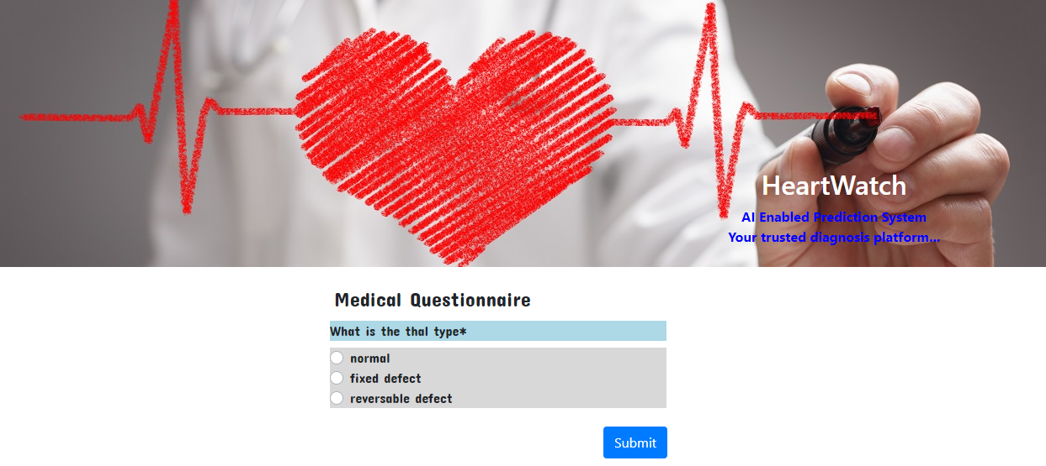

Figure . Questionnaire 1 (Question 1)

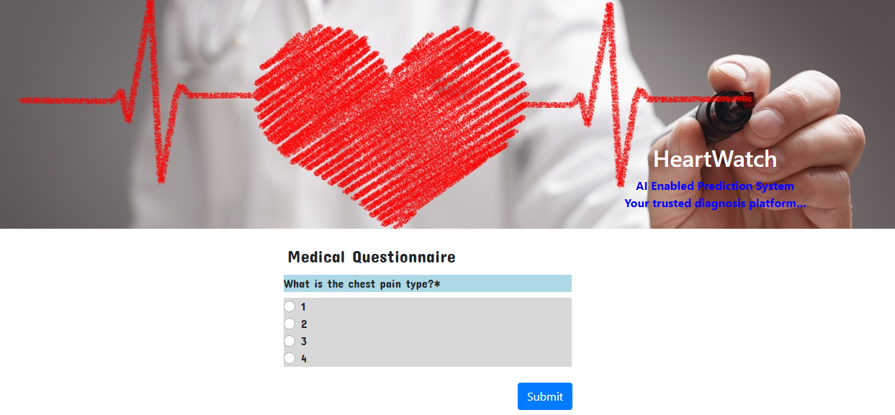

Figure . Questionnaire 1 (Question 2)

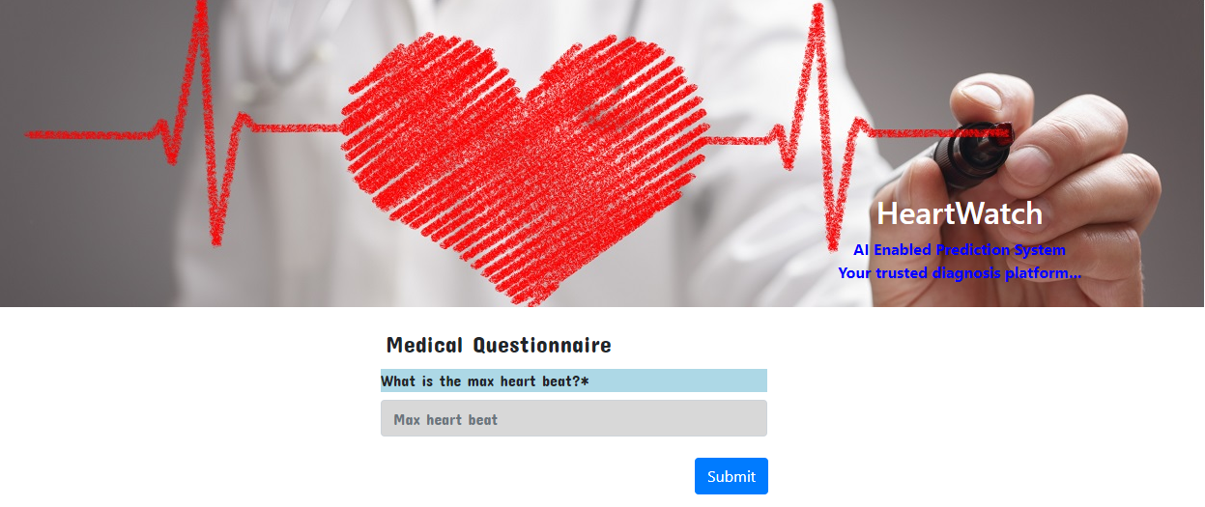

Figure . Questionnaire 1 (Question 3)

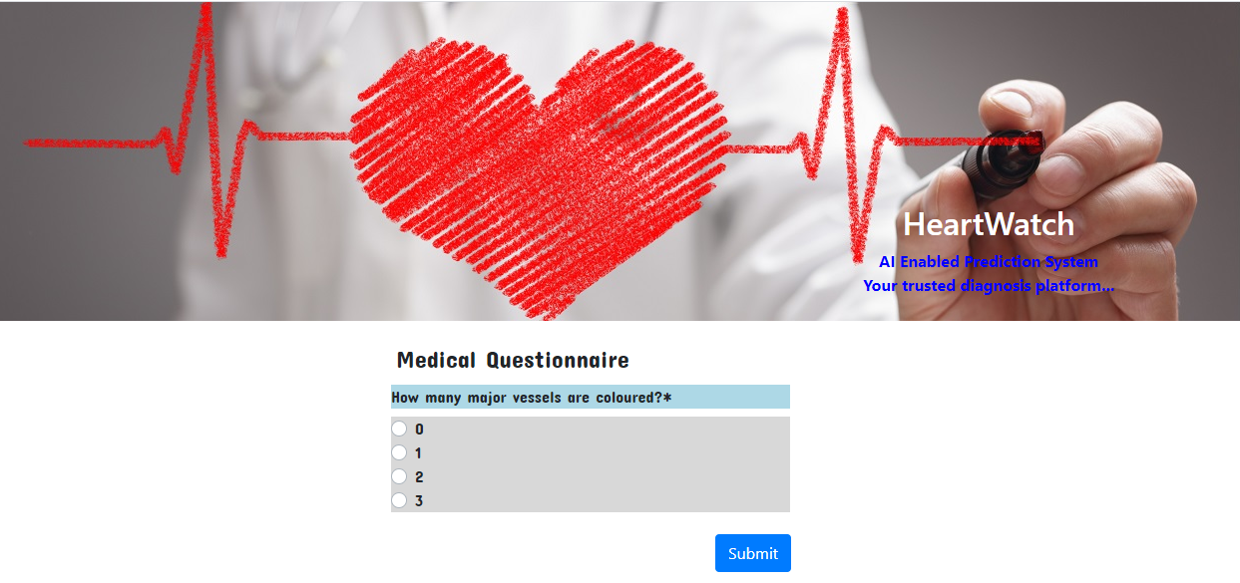

Figure . Questionnaire 1 (Question 4)

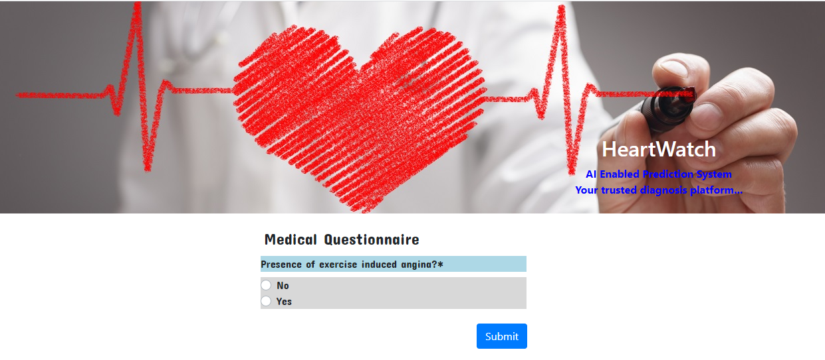

Figure . Questionnaire 1 (Question 5)

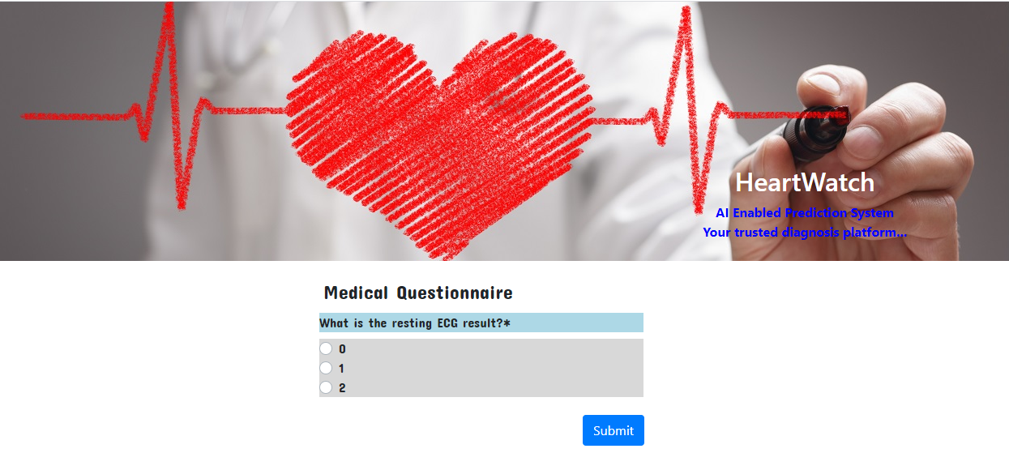

Figure . Questionnaire 1 (Question 6)

## Usage of Questionnaire View 2

Questionnaire 2 (Figure 4.7) consists of 3 questions which are related to patient’s lifestyle habits, such as smoking, and drinking of alcohol, which may contribute to a higher probability of the patient contracting CVD. The inputs from the user to Questionnaire02 will be used to derive an overall Certainty Factor (CF2), based on the probabilities of contracting CVD in respect of the lifestyle habits which are in-turn derived from the Hazard Ratios collected from a research paper by Stephanie E. Chiuve et al **[10]**. CF2 will then be combined with CF1 (certainty factor derived from inputs to Questionnaire01) in formula listed below to arrive at an overall Certainty Factor (CF) **[11]**. CF will be the final probability of the patient having CVD or not having.

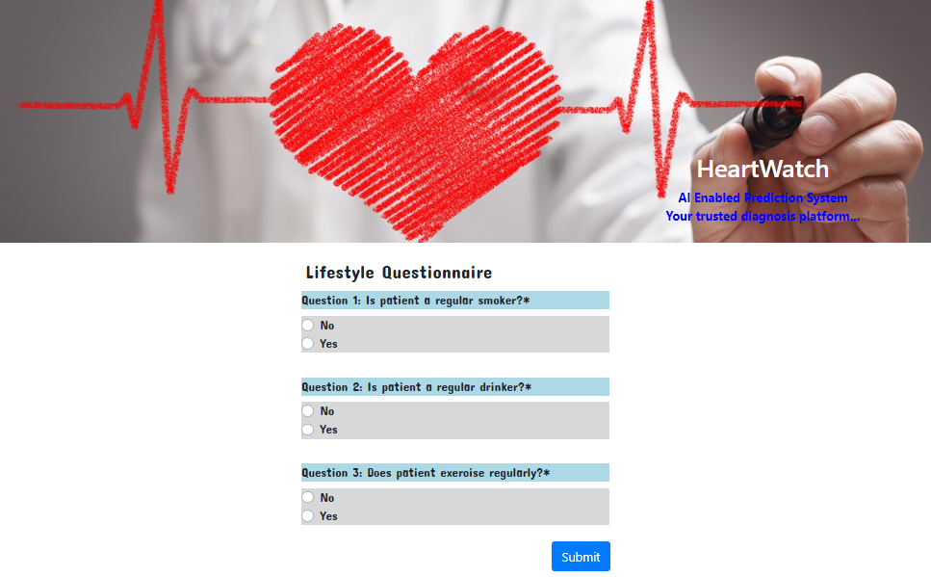

Figure . Questionnaire 2

A set of probabilities of a patient being diagnosed as having CVD is derived from the Hazard Ratios. The probabilities will be treated as Certainty Factors which will be combined with the probabilities derived from the answers submitted for Questionnaire 1.

Probability of patient being diagnosed with having CVD based on their lifestyle habits, derived from Hazard Ratios (HR):

$$P\left(CVD\right)=\frac{HR}{HR+1}$$

Combined Certainty Factors for multiple conclusions from Questionnaires 1 (CF1) and 2 (CF2):

$$CF=CF1+\left(1-CF1\right)×CF2$$

The corresponding Certainty Factors or probabilities of diagnoses for CVD in respect of the lifestyle habits of patients are shown in the following table.

Table . Certainty factors of contracting CVD with different lifestyle habits

|  |  |  |  |  |
| --- | --- | --- | --- | --- |
| Patient smokes | | Patient drinks alcohol | |  |
| Status | Probability for CVD | Status | Probability for CVD | Overall probability for CVD (CF2) |
| N | 0 | N | 0 | 0 |
| Y | 0.66 | N | 0 | 0.66 |
| Y | 0.66 | Y | 0.81 | 0.94 |
| N | 0 | Y | 0.81 | 0.81 |

## Result Page

The Result page (result.html) page shows the outcome of diagnosis for CVD. It contains the conclusion of whether a patient might be having CVD, and the probability of having or not having CVD. The 3 most indicative factors for the diagnosing on the contraction of CVD is also listed. Finally, a table, that contains a list of values for the various clinical measures and CVD-related lifestyle habits statuses, is displayed below. There are 6 critical clinical parameters identified in the generated decision tree. However,

the inputs to only 3 parameters are requested of the user by the application based on the input given by the user. The values of the other 3 parameters are displayed as “-1” which means there is no valid input for that parameter.

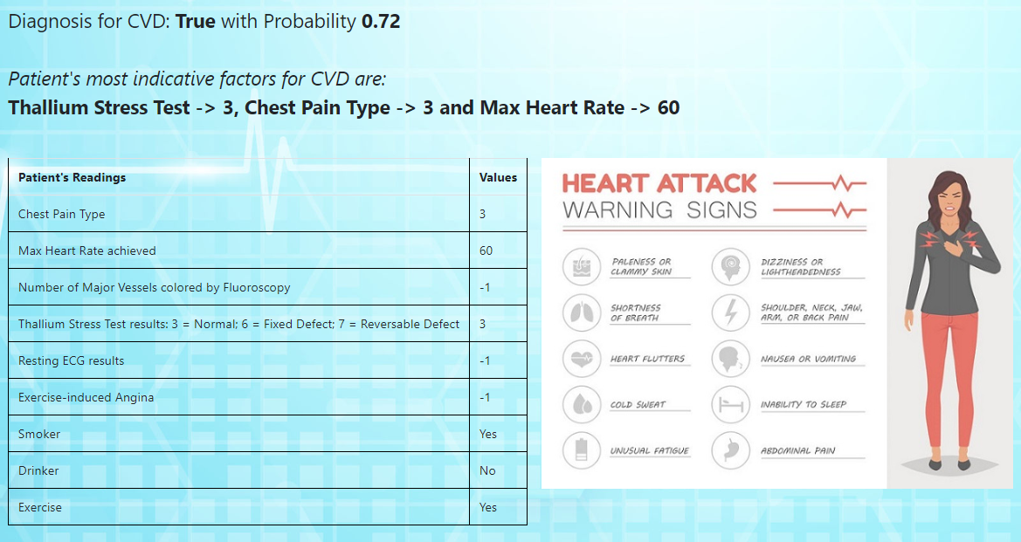

Figure . Result Page

# Conclusion

This application is a software-based medical diagnostic system, specifically to inform the user, who could be a medical professional or patient, about the likelihood of the patient contracting Cardiovascular diseases. There are multiple tests and clinical measures of a patient’s health status in relationship to the possibility of having CVD and there are also certain lifestyle practices of the patient which may increase their risk of contracting CVD. With this easy-to-use software application, the user is guided to answer the most relevant questions about their clinical measures and lifestyle habits, before being provided an accurate diagnosis of the probability of him contracting CVD. This provides a hassle-free procedure for not only clinical professionals, but also the layman patient, to quickly obtain some information about their health conditions, so that he or she may decide quickly whether to proceed with some further health checks and treatment in a timely manner.

A future improvement of this application, would be incorporate the Python-based machine learning libraries, such as Scikit-Learn, to generate the decision trees for future datasets that could be collected over time, so as to grow and evolve the knowledge-based decision tree model, which could then be updated into a Django-based database, such as SQLite. The application can then retrieve the updated rules during runtime from the database, and future users can access their health status for various diseases with newly trained model with new sets of patients data. Such a system constitutes an online machine learning platform, which means that its model-based rules engine is evolutionary and dynamically improving itself. Other machine learning techniques and models can be explored for knowledge and feature learning, such as support vector machine techniques, cluster analysis and even neural networks.

# References

[1] David w. Aha, 01-July-1988. Heart Disease Dataset. Machine Learning Repository. Retrived from URL <https://archive.ics.uci.edu/ml/datasets/Heart+Disease>

[2] Robert Detrano et al (1989). International Application of a New Probability Algorithm for the Diagnosis of Coronary Artery Disease*. The American Journal of Cardiology*, 64, 304-310.

[3] Orange. Retrieved from URL <https://orange.biolab.si/getting-started/>

[4] Graham J. Williams. Dec 2009. Rattle: A Data Mining GUI for R. The R Journal, 1 / 2, 45-55. Retrieved from URL <https://rattle.togaware.com/>

[5] Scikit-Learn. 2019. Retrieved from URL https://scikit-learn.org/stable/modules/generated/sklearn.tree.DecisionTreeClassifier.html

[6] David Beazley & Brian K.Jones. 7-March-2014. O'ReillyPython Cookbook 3rd Edition

[7] MDN web docs. 13-Nov-2019. Django Web Framework (Python). Retirived from URL <https://developer.mozilla.org/en-US/docs/Learn/Server-side/Django>

[8] Miguel Araujo & Daniel Greenfeld. 2019. django-crispy-forms. Retrieved from URL <https://django-crispy-forms.readthedocs.io/en/latest/index.html>

[9] Roberto Abdelkader et al. 16-Nov-2019. Experta Documentation. Retrieved from URL https://readthedocs.org/projects/experta/downloads/pdf/stable/

[10] Stephanie E. Chiuve et al. 14-Nov-2014. Lifestyle‐Based Prediction Model for the Prevention of CVD. Retrived from URL <https://www.ncbi.nlm.nih.gov/pmc/articles/PMC4338684/>

[11] The Chinese University of Hong Kong. Certainty Factor Model. Retrirved from URL <http://www1.se.cuhk.edu.hk/~seem5750/Lecture_5.pdf>

# Appendix 1: Project Proposal

**GRADUATE CERTIFICATE: Intelligent Reasoning Systems (IRS)**

**PRACTICE MODULE: Project Proposal**

|  |
| --- |
| **Date of proposal:**  18 March 2020 |
| **Project Title:**  ISS Project – Heart Watch - A diagnostic application for Cardiovascular Diseases |
| **Sponsor/Client:** *(Name, Address, Telephone No. and Contact Name)*  Institute of Systems Science (ISS) at 25 Heng Mui Keng Terrace, Singapore  NATIONAL UNIVERSITY OF SINGAPORE (NUS)  Contact: Mr. GU ZHAN / Lecturer & Consultant  Telephone No.: 65-6516 8021  Email: [zhan.gu@nus.edu.sg](mailto:zhan.gu@nus.edu.sg) |
| **Background/Aims/Objectives:**  The proposed intelligent diagnostic system for identifying patients with Cardiovascular Disease will make use of various advanced machine reasoning techniques and components to discover the underlying relationships between clinical, non-clinical parameters with CVD and to implement the trained model in the rule engine of a user-friendly application, which allows the clinical professional or patient to conduct a quick, effective and timely diagnosis of their CVD status with reasonable accuracy. |
| **Requirements Overview:**   * Research ability * Programming ability * System integration ability |
| **Resource Requirements (please list Hardware, Software and any other resources)**  Software proposed for consideration:   * Orange Machine Learning Software * Rattle Machine Learning Software * Scikit-Learn Python packages * Django packages and frameworks * Bootstrap * Crispyforms packages |
| **Number of Learner Interns required: (Please specify their tasks if possible)**  A team of four to three project members |
| **Methods and Standards:**   |  |  |  | | --- | --- | --- | | **Procedures** | **Objective** | **Key Activities** | | | **Requirement Gathering and Analysis** | The team should meet with ISS to scope the details of project and ensure the achievement of business objectives. | 1.        Gather & Analyze Requirements | | 2.        Define internal and External Design | | 3.        Prioritize & Consolidate Requirements | | 4.        Establish Functional Baseline | | **Technical Construction** | ·         To develop the source code in accordance to the design. | 1.        Setup Development Environment | | ·         To perform unit testing to ensure the quality before the components are integrated as a whole project | 2.        Understand the System Context, Design | | 3.        Perform Coding | | 4.        Conduct Unit Testing | | **Integration Testing and acceptance testing** | To ensure interface compatibility and confirm that the integrated system hardware and system software meets requirements and is ready for acceptance testing. | 1.        Prepare System Test Specifications | | 2.        Prepare for Test Execution | | 3.        Conduct System Integration Testing | | 4.        Evaluate Testing | | 5.        Establish Product Baseline | |  | | **Acceptance Testing** | To obtain ISS user acceptance that the system meets the requirements. | 1.        Plan for Acceptance Testing | | 2.        Conduct Training for Acceptance Testing | | 3.        Prepare for Acceptance Test Execution | | 4.        ISS Evaluate Testing | | 5.        Obtain Customer Acceptance Sign-off | |  | | **Delivery** | To deploy the system into production (ISS standalone server) environment. | 1.        Software must be packed by following ISS’s standard | | 2.        Deployment guideline must be provided in ISS production (ISS standalone server) format | | 3.        Production (ISS standalone server) support and troubleshooting process must be defined. | |  | |

**Team Formation & Registration**

|  |
| --- |
| Team Name:  Team 16 |
| Project Title (repeated):  Heart Watch - A diagnostic application for Cardiovascular Diseases |
| System Name (if decided):  Heart Watch |
|  |
| Team Member 1 Name:  Pee Kian Soon |
| Team Member 1 Matriculation Number:  A0213510B |
| Team Member 1 Contact (Mobile/Email):  9785 5410 / e0508611@u.nus.edu |
|  |
| Team Member 2 Name:  Mahathir bin Humaidi |
| Team Member 2 Matriculation Number:  A0213486A |
| Team Member 2 Contact (Mobile/Email):  9477 8776 / e0508587@u.nus.edu |
|  |
| Team Member 3 Name:  Tang Shao Qiang |
| Team Member 3 Matriculation Number: A0213558A |
| Team Member 3 Contact (Mobile/Email):  9699 2778 / e0508659@u.nus.edu |
|  |
| Team Member 4 Name: |
| Team Member 4 Matriculation Number: |
| Team Member 4 Contact (Mobile/Email): |
|  |
| Team Member 5 Name: |
| Team Member 5 Matriculation Number: |
| Team Member 5 Contact (Mobile/Email): |
|  |
| Team Member 6 Name: |
| Team Member 6 Matriculation Number: |
| Team Member 6 Contact (Mobile/Email): |
|  |

|  |  |  |
| --- | --- | --- |
| **For ISS Use Only** | | |
| **Programme Name:** | **Project No:** | **Learner Batch:** |
| **Accepted/Rejected/KIV:** | | |
| **Learners Assigned:** | | |
| **Advisor Assigned:**  Contact: Mr. GU ZHAN / Lecturer & Consultant  Telephone No.: 65-6516 8021  Email: [zhan.gu@nus.edu.sg](mailto:zhan.gu@nus.edu.sg) | | |

# Appendix 2: System Functionalities and Course Work Knowledge

The following table summarizes the System functions or features of our application and the Course Modules and chapters that have provided the motivation and inspiration for their implementation.

|  |  |  |  |
| --- | --- | --- | --- |
| **Project Report** | | **Coursework** | |
| **System Functions** | **Chapters** | **Course Module** | **Chapter** |
| Knowledge acquisition and discovery: Decision Tree Generation | 2.3 | Machine Reasoning | Day 3 |
| Reasoning Systems | Day 4 |
| Rule Engine Implementation | 3 | Machine Reasoning | Day 2 |
| Intelligent Business Logic | 3 | Machine Reasoning | Day 2 |
| Reasoning Systems | Day 5 |
| Inference under uncertainty: combining multiple conclusions | 4.3 | Machine Reasoning | Day 3 |

# Appendix 3: Installation and User Guide

## 1 Deployment

**1.1 Supported Browsers**

* Firefox 76
* IE 11
* Google Chrome 81

**1.2 Backend Dependencies (Packages)**

The system runs on Django – a Python-based free and open-source web framework. To run the system successfully, some basic packages are required with the latest version of Python 3 (i.e. 3.82).

* pip install Django
* pip install django-crispy-forms
* pip install experta

**1.3 Deploy in Local Machine**

Open the command prompt terminal and change the working directory to "mysite". Please ensure that all required dependencies as mentioned earlier are successfully installed before proceeding else you will end with build failures.

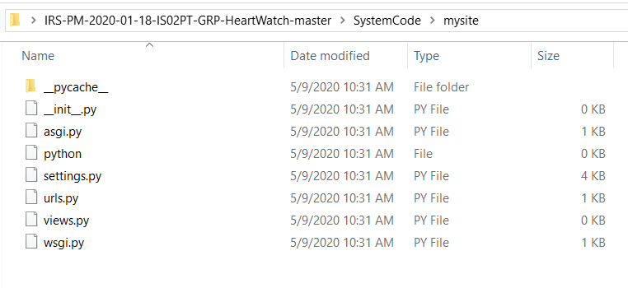

Run the command "python manage.py runserver" in the command prompt. You should see the following output on the command prompt.

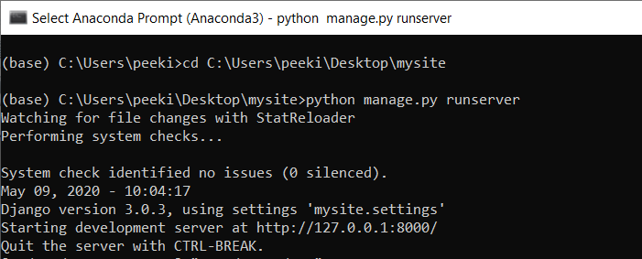

Open a web brower to access the URL "[http://127.0.0.1.8000/](http://127.0.1.8000/) to start using the App.

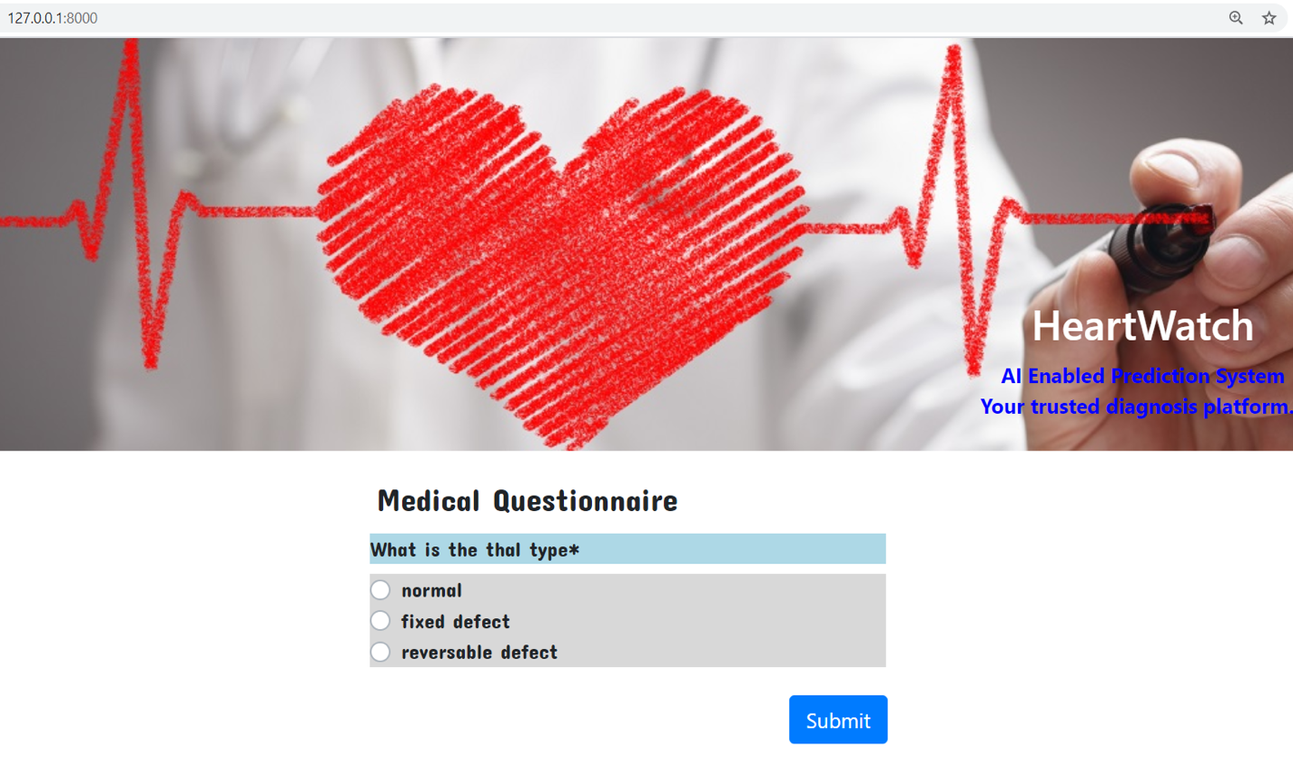

**2 Test Cases**   
  
In this section, we will take a look at some test cases of our system and an analysis of the output will be given.

**2.1 Test Case 1**

This test case predicts the likelihood of CVD in a patient with thal type = reversable defect, no. Of major vessels coloured = 3 and resting ECG = 0 and with healthy lifestyle. Based on the Decision Tree (Rule-Set) Classifier, the prediction should be Turewith Probability of **0.8.**

Medical Questionnaire

*Q1. What is the thal type\**

*Ans: 3*

*Q2. How many major vessels are coloured?\**

*Ans: 3*

*Q3. What is the resting ECG result?\**

*Ans: 160*

Lifestyle Questionnaire

*Q1. Is patient a regular smoker?\**

*Ans: No*

*Q2. Is patient a regular drinker?\**

*Ans: No*

*Q3. Does patient exercise regularly?\**

*Ans: No*

Screenshot of Results

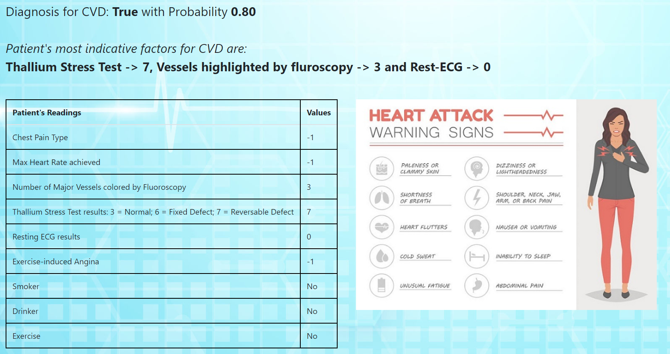

*\*\*Parameter's value of “-1” which means there is no valid input for that parameter.*

**2.2 Test Case 2**

This test case predicts the likelihood of CVD in a patient with thal type = normal, chest paint type = 3 and max heart beat = 160 and with healthy lifestyle. Based on the Decision Tree (Rule-Set) Classifier, the prediction should be **False** with Probability of **0.83.**

Medical Questionnaire

*Q1. What is the thal type\**

*Ans: normal*

*Q2. What is the chest pain type?\**

*Ans: 3*

*Q3. What is the max heart beat?\**

*Ans: 160*

Lifestyle Questionnaire

*Q1. Is patient a regular smoker?\**

*Ans: No*

*Q2. Is patient a regular drinker?\**

*Ans: No*

*Q3. Does patient exercise regularly?\**

*Ans: No*Screenshot of Results

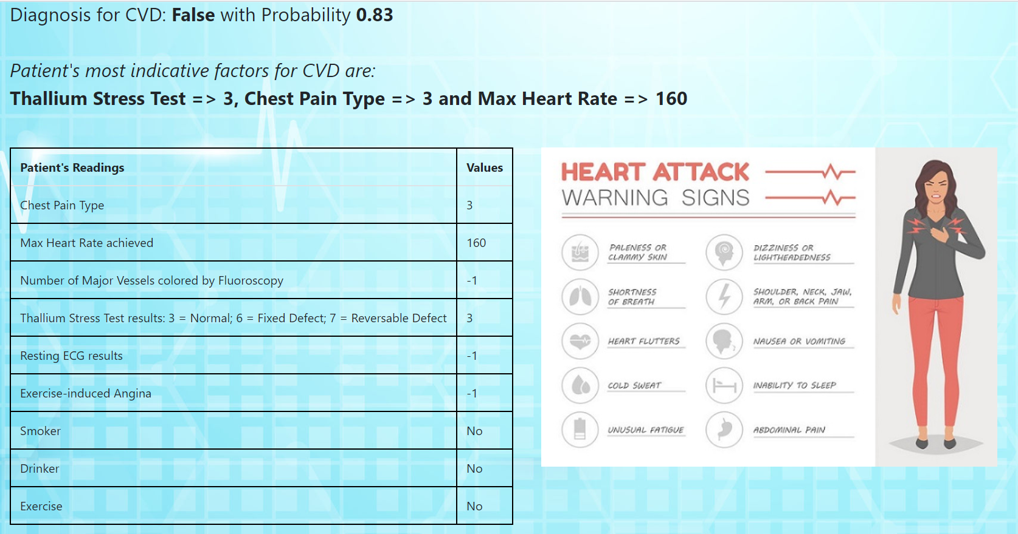

*\*\*Parameter's value of “-1” which means there is no valid input for that parameter.*

**2.3 Test Case 3**

This test case predicts the likelihood of CVD in a patient (Smoker) with thal type = normal, chest paint type = 3 and max heart beat = 160 and with healthy lifestyle. Based on the Decision Tree (Rule-Set) Classifier, the prediction should be **True** with Probability of **0.72.**

Medical Questionnaire

*Q1. What is the thal type\**

*Ans: normal*

*Q2. What is the chest pain type?\**

*Ans: 3*

*Q3. What is the max heart beat?\**

*Ans: 160*

Lifestyle Questionnaire

*Q1. Is patient a regular smoker?\**

*Ans: Yes*

*Q2. Is patient a regular drinker?\**

*Ans: No*

*Q3. Does patient exercise regularly?\**

*Ans: No*Screenshot of Results

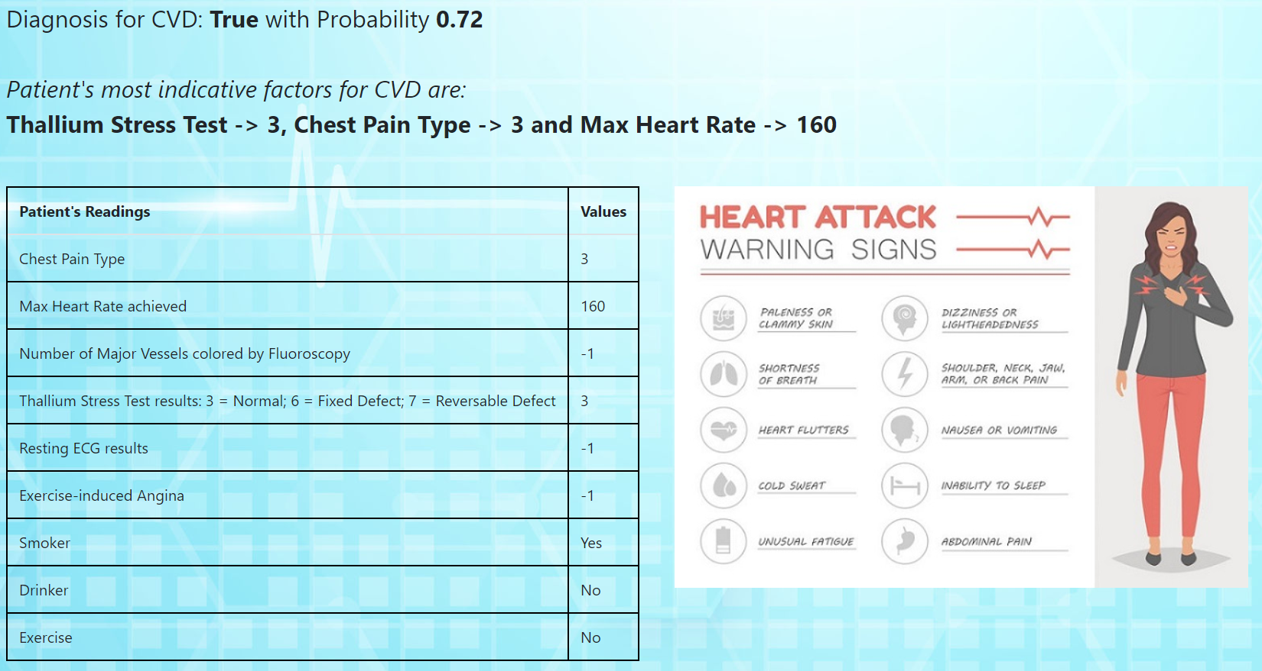

*\*\*Parameter's value of “-1” which means there is no valid input for that parameter.*

# Appendix 4: Personal Report

**Personal report of Pee Kian Soon**

This course "Intelligent Reasoning Systems" really opened up my horizon in AI. AI is not all about machine learning and deep learning; in fact ML and DL are just a small subset of the whole AI ecosystem. I was introduced to fundamental topics in AL like problem formulation, search algorithms, first order logic, Knowledge Representation and Reasoning, fuzzy logic etc which are both mind stimulating and important for a good foundation in AI.

I am glad to consolidate and demonstrate my understanding by applying what i learn in the course to the project module. From the project, i gained a better appreciation of the full-stack process (and methodology like CRISP-DM) through analysis of business case, knowledge extraction from data mining, apps creation and deployment. It also give me an opportunity to improve my programming skills through the frontend and backend coding work.

I had an amazing time working with my team mates; Shao Qiang and Mahathir. We were able to leverage on one another strengths and knowledge. There was a lot of knowledge sharing, cross pollination of ideas and most importantly camaraderie. A great portion of our time was spent on reading up literatures and references to further bolster our understanding in certain topics like KRR decision tree, certainty factors etc. We tried out various AI tools and realised that many tools are available for the same general tasks but depending on the task details, some tools may be more suitable than others. For example, we noticed that unlike Orange, Scikit-Learn was not able to handle categorical variables in decision tree.

I conducted frontend studies of ex-ISS rpojects and shared the findings to the team. Subsequently i also came out with the project idea (HeartWatch) after combing through online resoucres like kaggle, UCI etc and proposed the reasoning system architecture (decision tree => ruleset => rule engine). I mastered and introduced Django (+ cripsyform) and Experta to the team and together with Shao Qiang, we did the coding for both the frontend and backend system. I also created the user guide and tried (but failed) to deploy the apps on Heroku.

**Personal report of Tang Shao Qiang**

I have always been interested to learn about and implement machine learning and AI techniques in my work or for personal interests. The first semester of the ISS course has given me a good introduction to the foundation of machine learning, and has provided in-roads for me into the more rigorous theoretic approach to analysing data, developing effective models, and evaluating the effectiveness of such models when applied to future datasets for predictive purposes. I am also inspired by the exposure to numerous softwares and platforms that are versatile tools for the engineers or various other professions to implement data mining, pattern recognition and to develop cognitive hybrid systems that can intelligently guide and streamline the business processes of the various professions.

Our semester project involves developing a user-friendly application that takes in clinical measures and other parameters from the user and puts these values through a process of matching with pre-coded rules, after which a diagnosis will be made with regards to the possibility of a patient having CVD. In the process of working on this project, my team members and I have had the opportunity to be exposed to various softwares that help us train up effective models with our dataset. Our team has utilized the Orange and Rattle softwares for generating decision trees and performing cross-validation on the dataset. While Orange and Rattle have versatile GUIs for performing data loading and setting the various parameters for decision tree generation and cross validations, we have also explored Scikit-Learn packages that can perform decision tree classification too and was considered as there is a possibility for easy integration of the knowledge discovery module with the rules engine. However, due to the lack of ability of Scikit-Learn to process categorical variables for the decision-tree classifier, the decision tree generated by Orange is selected for use in the rule engine, as it gives a lower entropy at the leave nodes. Also, by generating decision trees of various depths, we discover that a tree of 3 layers gives the best AUC values, as well as other performance metric. I have been mainly involved in using Scikit-Learn package to train the decision tree classifier and perform cross validation, for which the results were compared with those generated by Orange, which carried out by my other team-mates. Also, I have implemented a business logic in the Django views to enable a dynamic selection of questions to be delivered to the user, the sequence of which depends on the user’s input for the earlier queries. The sequence is also dependent on the flow across the various branches of the decision tree that the application uses. Through exploring the use of different softwares and API framworks by each team member, our team is able to leverage on each other’s expertise, for verification, integration and optimization of our works.

With the comprehensive knowledge and confidence in actual implementation of machine learning techniques in real applications gained through this course, I am very motivated to use the tools I have learnt on knowledge-based decision making systems for the projects in my work. Such systems can reduce the amount of human efforts at performing monitoring tasks and decision making at implementing mitigation tasks can be achieved much faster, when the system is able to provide recommended actions for the operators on site to take, in response to real-time situations. Also, with the use of online, hybrid cognitive systems, data acquisition and knowledge discovery or feature detection can be performed in real-time, so that the knowledge-based rule engine of the decision-making module of the system can be evolve in real-time and thus becomes truly an adaptive, intelligent system.

**Personal report of Mahathir bin Humaidi**

I am extremely grateful to be given the chance to partake in this AI course at NUS ISS. Although the learning curve is steep, the guidance and encouragement from instructors and team-mates had been very motivating. I am aware that I have much to learn but I will try my best to stay the course.

With regards to the practice module, I am blessed to be working together with my current team-mates. We started with the idea of making a portal for Social Services. We were very motivated and even met up with one of the managers of Social Service Institute. She was the one who spearheaded the Social Service Navigator Portal. We were aiming to value add to her portal by utilising ML techniques. However, SSI wasn’t too keen on our idea and we had to return back to the drawing board. We spent almost 2 weeks before Kian Soon came out with the idea to use the UCI ML heart disease dataset. It was a godsend. Hence, we decided on this path and started anew.

During the development of our software, I was required to read up first fundamentals of classification methods. I picked up decision tree making using R and Orange in order to derive rules for our program. When Shan Qiong presented the Mid-project presentation, Sam commented that we should run cross-validation tests on our decision tree. From there, I realised that Rattle did not have that feature. I was really hooked on Rattle due to its easy-to-use nature. However, I needed to turn to Orange Data Mining Suite to achieve the robustness required by Sam.

As the lessons proceed, I hope to learn and be more proficient in this field, and contribute significantly in my career at NEA. Thank you ISS, Thank you Group 16!